Fix this NPM Not Found In Powershell : run following commands  
step 1,2

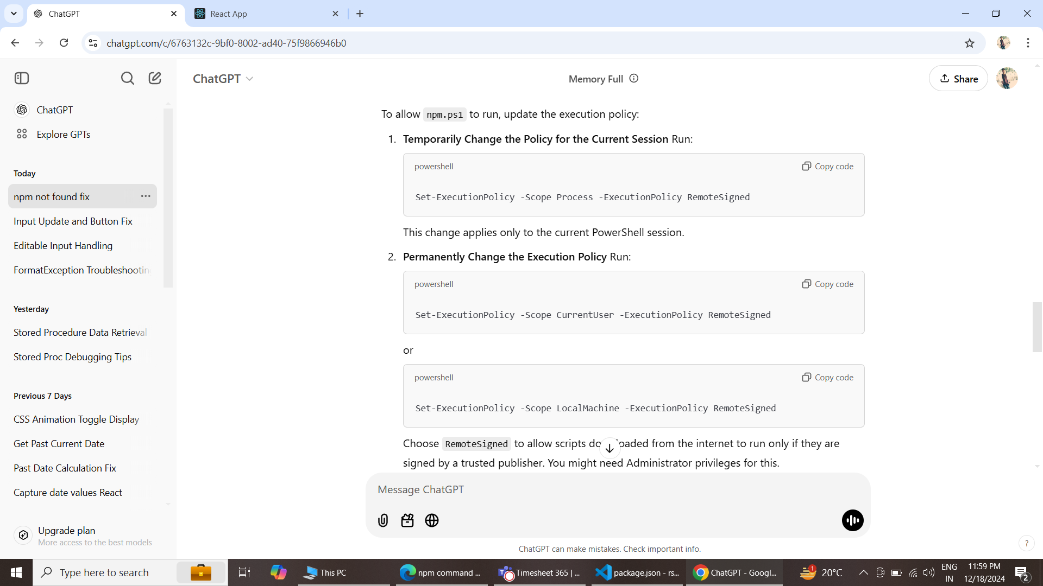

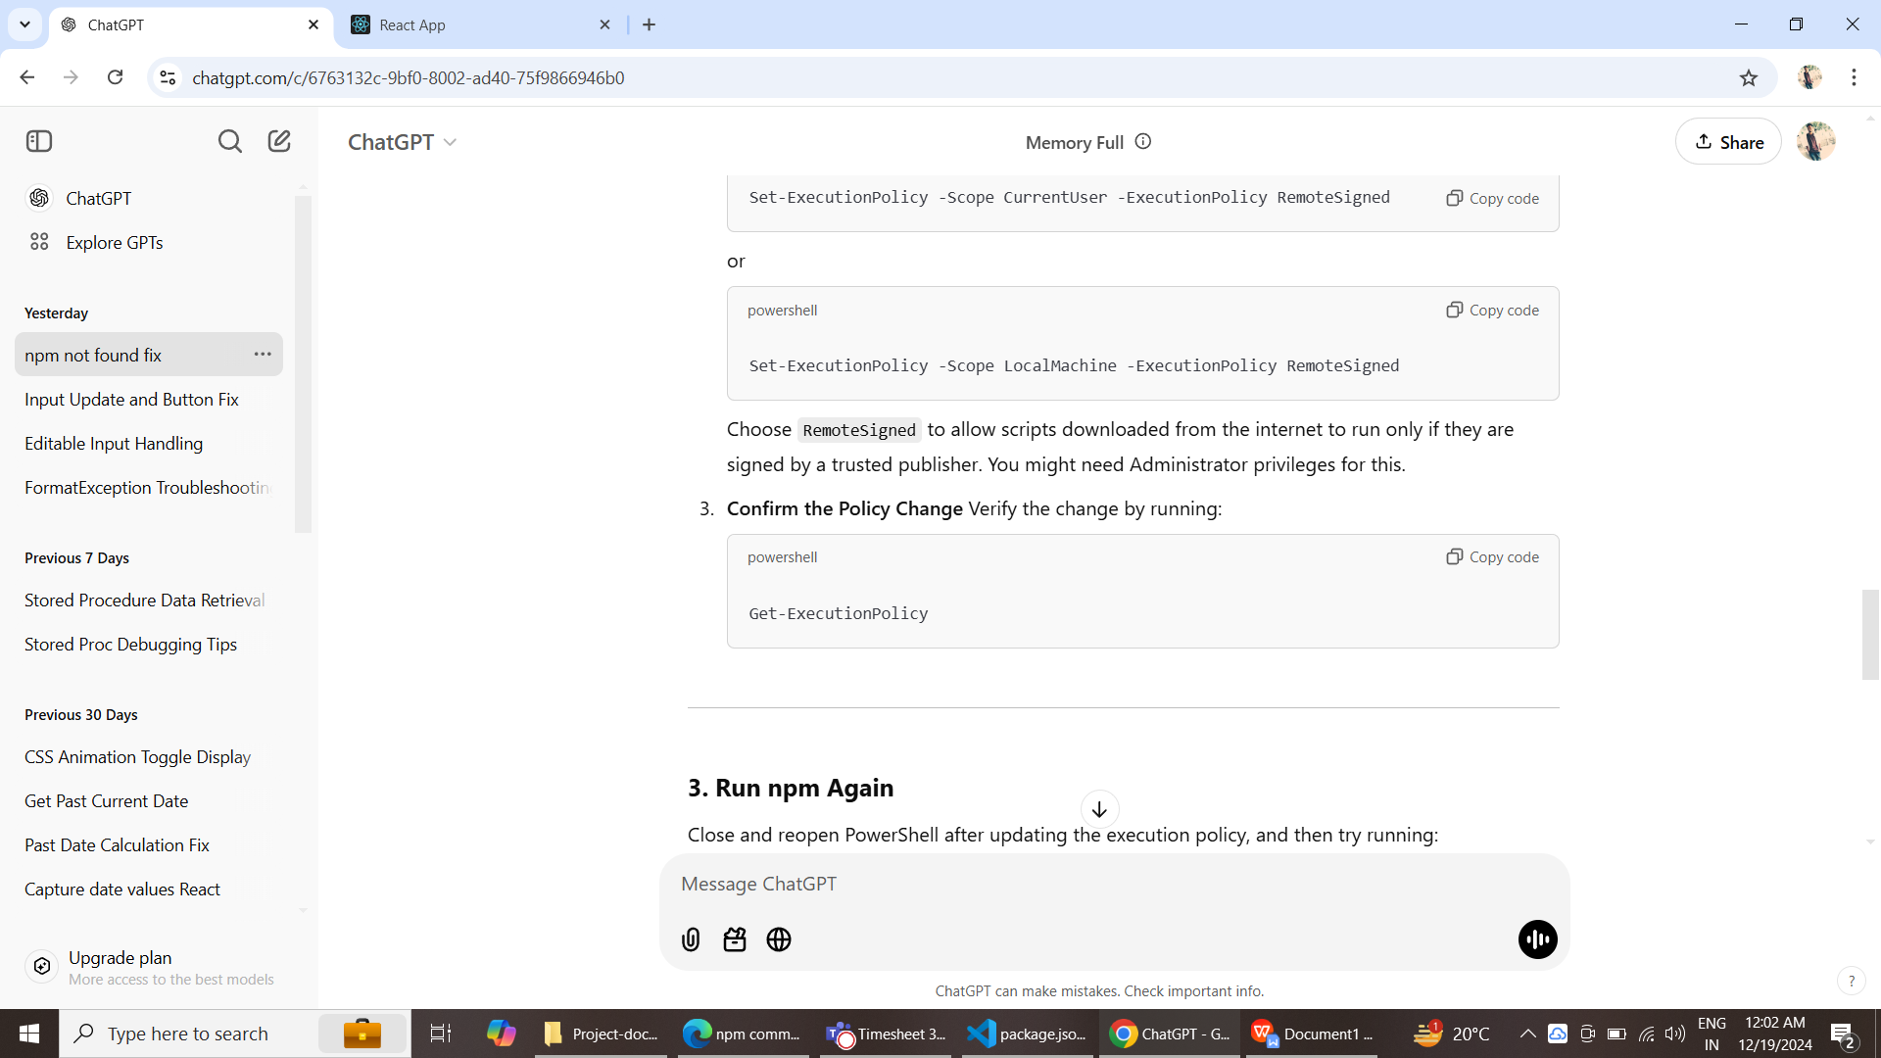  
  
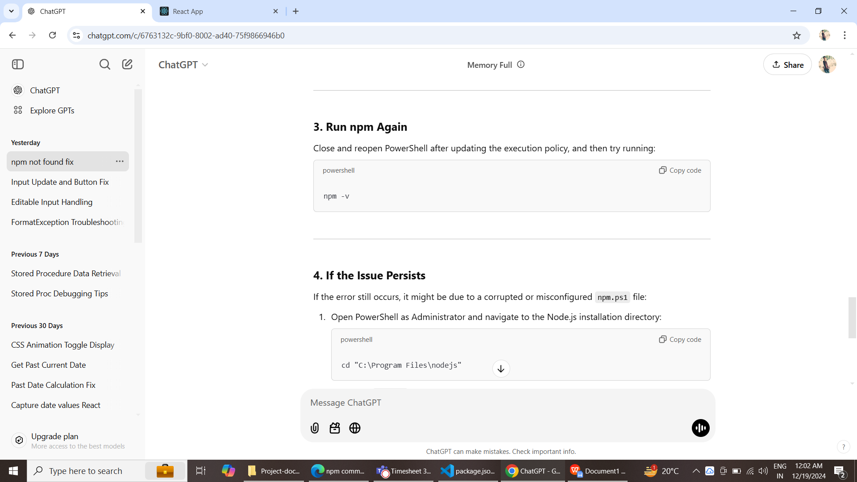  
  
Then check npm -v in your power shell   
now its starts working in your pc.